|  |  |  |  |  |  |  |  |  |  |  |  |  |  |  |  |  |  |  |  |  |  |  |  |  |
| --- | --- | --- | --- | --- | --- | --- | --- | --- | --- | --- | --- | --- | --- | --- | --- | --- | --- | --- | --- | --- | --- | --- | --- | --- |
| |  |  | | --- | --- | | For office use only | | | T1 | ________________ | | T2 | ________________ | | T3 | ________________ | | T4 | ________________ | | |  | | --- | | Team Control Number **19379454** | | **D** | | |  |  | | --- | --- | | For office use only | | | F1 | ________________ | | F2 | ________________ | | F3 | ________________ | | F4 | ________________ | |

**IMMC 2019**

**The 5th Annual International Mathematical Modeling Challenge (Winter Contest)**

**Summary Sheet**

As the industries and other human activities increase, the atmosphere pollution is getting worse currently, causing atmosphere problems such as atmospheric haze and others. In this essay, we will discuss the diffusion pattern of the gas pollutants.

In our first model, we solve the first question to confirm the site of three pollution sources. According to the Maxwell's Velocity distribution, we can get the concentration distribution of the pollutants in any distance from the source. Then we use this formula backwards and solve the three sites. Besides, in order to examine the result of our model, we construct another model according to the Navier-Stokes equation. In this sub model, we use ADI (Alternating Direction Implicit Method) to solve this equation to get another concentration distribution and compare it with the given distribution.

In the second model, we take the velocity of the wind into our consideration. In this way, we improve our former model which is based on the Navier-Stokes and secondly simulate this model to get another concentration distribution with the influence of the wind.

In our third model, we model the government’s expenditure in controlling and reducing the emission of the pollutants. We can first get the expression for the fund of a year to deal with a certain amount of pollutants. Then, we get the expression foe the total expenditure in the 5 years with the interest rate of the bank loans.

Finally, we do the sensitivity analysis on our model to examine the stability and validity of our model and find it perform well.

|  |
| --- |
| Curbing Environmental Pollution Team#19379454  Feb.2, 2019 |

Contents

1. Introduction 4

1.1 Background 4

1.2Problem Restatement 4

1.3 Literature Review 4

2. General Assumptions 4

3. Model A: Locate the three sources of air pollution 5

3.1 Model Overview 5

3.2 Model Assumption 5

3.3 Variables of Model A 6

3.4 The amount of pollutant 6

3.5 Locate the three sources of air pollution 7

3.6 Verification model 8

4. Model B: Establishment of Wind concluded distribution 12

4.1 Model Overview 12

4.2 Variables of Model B 12

4.3 Wind concluded distribution 12

5. Model C: The annual budget 18

5.1 Model overview 18

5.2 Variables of Model C 18

5.3 The annual budget 18

6 Sensitive Analysis 19

6.1 Sensitivity analysis of v and a 19

7. Strengths and weaknesses 20

7.1 Strengths 20

7.2 Weaknesses 20

8. References 21

1. Introduction

## 1.1 Background

Most economic theories always neglect the impact of the constructing activities on the ecosystem. However, the environment is facing its consequence now. The air pollution has been a serve problem with the increasing of the human industrial and social activities, causing atmosphere problems such as atmosphere haze and others. At this point, monitoring and controlling the emission of air pollutants has become a critical issue.

## 1.2Problem Restatement

We are required to qualify the spread of air pollutants in no-wind condition and in wind condition. Through that model, we are able to figure out the best solution of pollution reduction.

1 Figure out the exact position of the three sources of air pollution through our mathematical model.

1. Based on Model A, add the factor of wind including wind velocity and the angle of the direction of wind.
2. Hand a solution for the government concerning the factor of comprehensive treatment expenses and special treatment expenses and the interest of loans.

## 1.3 Literature Review

In Model A, Maxwell distribution is utilized to figure out the spread of air pollutants in no-wind condition. We made several assumptions to make the method capable for the issue. Based on that, we are able to figure out the exact position of the three sources of air pollution through our mathematical model.

In Model B, the Navier-Stokes equation is used to figure out the spread of air pollutants in wind condition. Based on Model A, we added the factor of wind including wind velocity and the angle of the direction of wind.

1. General Assumptions
2. We assume that chemical reaction do not occur between those pollutants.

For chemical reaction cannot be predicted and evaluated in this problem, we do not consider the probability of chemical reaction.

1. We assume that the amount of pollutant each source of air pollution release is constant and equal.

Since tiny wave of the amount of pollutant exists, it has such little influence that we can ignore it.

1. We assume that the pollutant will not be absorbed by the ground or any obstacle.

Since it cannot be evacuated and it has a very tiny impact to the distribution, we do not take this into consideration.

1. We do not take the fluctuation of the ground into consideration.

Since it cannot be evacuated and it has a very tiny impact to the distribution, we do not take this into consideration.

5. We use an hour as the minimum unit.

The minimum unit given in the subject is an hour.

1. Model A: Locate the three sources of air pollution

## 3.1 Model Overview

In this model, we research the pattern in which the air pollutants emit regardless the affection of the wind. In our consideration, the velocity distribution of the gas molecules can be normally distributed according to the Maxwell distribution. In this way, we can get the concentration of the pollutant according to its distance to the source. Then, we use an expected difference estimation to get the optimal solution for the sites of the three sources. Finally, in order to verify the validity of our model, we substitute the result into the ns equation to get another concentration distribution for the pollutant and compare it with the one given to make sure our model’s correctness.

## 3.2 Model Assumption

**1. We assume that the velocity of a specific molecule is constant.**

*Since the total figure of pollutant molecules is confirmed by the Maxwell distribution, the velocity change of a specific molecule will not influence anything in total figure.*

## 3.3 Variables of Model A

**Table 1** Variables of Model A

|  |  |
| --- | --- |
| Variables | Definition |
| $$s_{ij}$$ $t_{i}$ $$v_{i}$$ $$n_{i}$$ Z  f(x,y,t) $$G_{t}$$ | the distance between the pollutant source and point $\left(i,j\right)$ the time point a molecule is released  a constant velocity that a specific molecule has  the pollutant amount released at $t_{i}$ at the angle of $θ$ while moves at the speed of $v_{i}$ an evaluation index  the [velocity](javascript:;) at which polluting gases are emitted  the partial [differential](javascript:;) of concentration with respect to time |

## 3.4 The amount of pollutant

According to the Maxwell distribution mentioned in **Figure 1**, the total figure of pollutant molecules is confirmed.

$$f\left(v\right)=4π{(\frac{m}{2πkT})}^{\frac{3}{2}}∙e^{-\frac{mv^{2}}{2kT}}∙v^{2} \left[1\right]$$

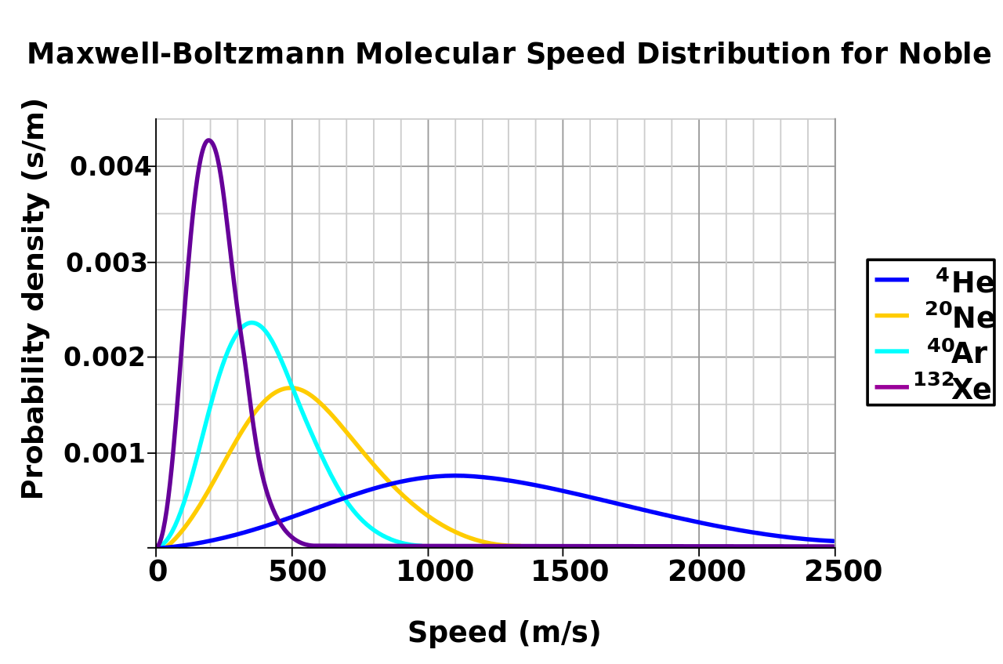

**Figure 1** the Maxwell distribution

To a given point $(i,j)$, we assume that the distance between the pollutant source and point $(i,j)$ is $s_{ij}$. We assume that a molecule is released at the time point $t_{i}(i∈\left[1,100\right]$). And each of that molecule has a constant velocity $v_{i}(i∈\left[1,100\right]$), the pollutant amount released at $t_{i}$ at the angle of $θ$ while moves at the speed of $v_{i}$ is $n_{i}$.

Since the time of the molecule move is ${100-t}_{i}$, we can figure out that, $$v=\frac{s}{{100-t}_{i}} (1)$$

Since $n_{i}$ can be figure out through the Maxwell distribution, we can evaluate n through integral:

$$n=\int_{0}^{100-ε}{f(v)dt} (2)$$

, in which $ε$ is an infinitesimal.

Thus, we combine $(1)$ with $(2)$:

$$n=\int_{0}^{100-ε}{f(\frac{s}{100-t_{i}})dt}$$

After that, we consider it in three dimension. We integrate it from 0 to $\frac{π}{2}$ in order to figure out the total amount in three dimension:

$$n=\int_{0}^{\frac{π}{2}-ε}{\int_{0}^{100-ε}{f(\frac{s}{(100-t_{i})})dtdθ}}$$

## 3.5 Locate the three sources of air pollution

First of all, we definite three distance:

$$s_{1}=\sqrt{{(x_{1}-i)}^{2}+{(y_{1}-j)}^{2}}$$

$$s_{2}=\sqrt{{(x_{2}-i)}^{2}+{(y_{2}-j)}^{2}}$$

$$s_{3}=\sqrt{{(x_{3}-i)}^{2}+{(y_{3}-j)}^{2}}$$

Using the data given by the problem (the Excel file D01.xlsx.), we can build an evaluation index z, where:

$$z_{min}={\sum_{i=0,j=0}^{100}{(\int_{0}^{\frac{π}{2}-ε}{\int_{0}^{100-ε}{f(\frac{s_{1}}{(100-t_{i})})dtdθ}}+\int_{0}^{\frac{π}{2}-ε}{\int_{0}^{100-ε}{f(\frac{s_{2}}{(100-t_{i})})dtdθ}}}+\int_{0}^{\frac{π}{2}-ε}{\int_{0}^{100-ε}{f(\frac{s_{3}}{(100-t_{i})})dtdθ}}-f(i,j))}_{min}$$

, in which $f(i,j)$ is the data given by the Excel file D01.xlsx.

By utilizing Matlab, we can locate the three sources of air pollution through finding the minimum of z through iteration.

The result of the location of the three sources of air pollution is (47, 65), (34, 51), (69, 47) which is printed red in the following figure:

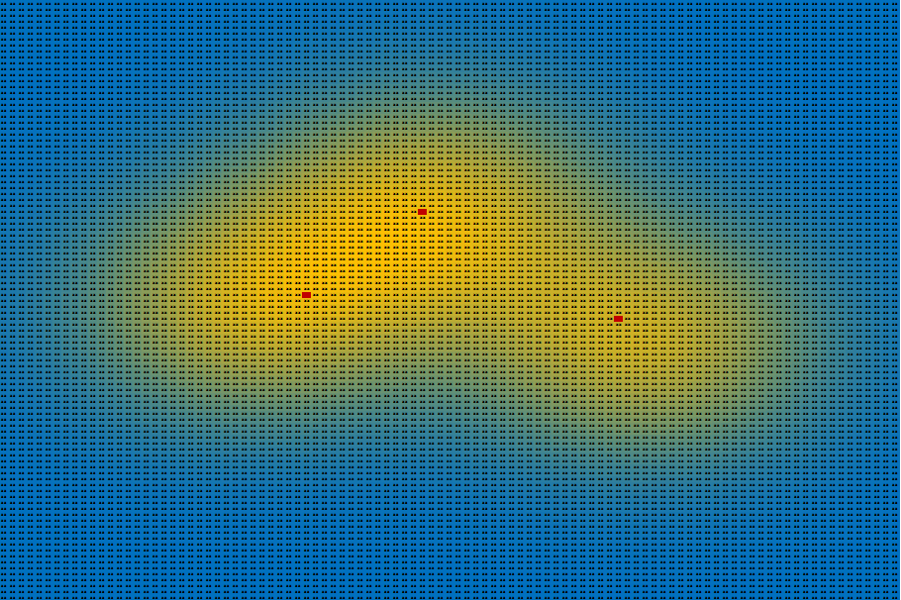

**Figure 2** the location of the three sources of air pollution

## 3.6 Verification model

Since our former model is based on the molecular level distribution to analyze the concentration distribution of the pollutants, the deviation may be a bit large. In this situation, we use a molecular diffusion model for continuous point sources which research the emission pattern of the gas at the macro level to simulate another emission situation with the results of the former model. And then we compare this emission distribution with the one given by the last model to examine and restore our model.

First, we apply the NS equation (Navier-Stokes equations), and then we can get another emission pattern of the model:

$$\frac{∂G}{∂t}=a∆u+f\left(x,y,t\right) \left[3\right]$$

In this model, the $a$ is the [diffusion](javascript:;) [coefficient](javascript:;), the Δ is the [Laplace](javascript:;) [operator](javascript:;), which equals:

$$∆=\frac{∂^{2}}{∂x}+\frac{∂^{2}}{∂y}$$

And the f(x,y,t) is the [velocity](javascript:;) at which polluting gases are emitted, which equals the original velocity at the place where the factory was built, and equals 0 where there is not a factory, which can be represented by the following equations:

$$f\left(x,y,t\right)=f\left(x\right)=\left\{\begin{aligned}v, &x=x_{i},y=y_{i},i=1,2,3 \\ 0, &other\end{aligned}\right.$$

When the upper and lower air is sufficiently convected, the concentration distribution of the pollutants in every horizontal plane should be the same, for the pollutants should have emitted [adequately](javascript:;). In this way, we only calculate the concentration emission in an x-o-y plane.

Then, we can combine the equation above and get the following equation:

$$G_{t}=a(G_{xx}+G_{yy}) +f(x,y,t)$$

Where $G_{t}$ is the partial [differential](javascript:;) of concentration with respect to time, the $G_{xx}$ and $G_{yy}$ is the second partial [differential](javascript:;) of u with respect to location.

And now we take the Initial boundary condition into account. At the initial moment, the concentration at each point on the plane is 0, so we get:

$$G\left(x,y,0\right)=0 x,y∈\left[0,100\right]$$

We choose the continuation boundary conditions, and get:

$$G\left(0,y,t\right)=G\left(100,y,t\right)=G\left(x,0,t\right)=G\left(x,100,t\right)=0$$

$$x,y∈\left[0,100\right]$$

In this way, we get the diffusion model for continuous point sources regardless the impact of wind velocity:

$$\left\{\begin{aligned}G_{t}=a\left(G_{xx}+G_{yy}\right)+f\left(x,y,t\right) (1) \\ G\left(0,y,t\right)=G\left(100,y,t\right) x,y∈\left[0,100\right] (2) \\ G\left(x,0,t\right)=G\left(x,100,t\right)=0 x,y∈\left[0,100\right] (3) \\ G\left(x,y,0\right)=0 x,y∈\left[0,100\right] (4)\end{aligned}\right.$$

Then, we will research for the diffusion coefficient of the pollutants in the air. For the definition of the diffusion coefficient:

$$D=\frac{435.7T^{\frac{3}{2}}}{p{(V_{A}^{\frac{1}{3}}+V_{B}^{\frac{1}{3}})}^{2}}\sqrt{\frac{1}{μ_{A}}+\frac{1}{μ_{B}}}{cm}^{2}/s$$

In this way, we can calculate the diffusion coefficient of the air is about 10.

Then in order to get the solution of the equation, we use the ADI (Alternating Direction Implicit Method) to solve the method, for it is often used in solving such diffusion equations.

In this way, we turn the equation 1 into the ADI format and get:

$$\frac{G_{α,β}^{n+\frac{1}{2}}-G_{α,β}^{n}}{\frac{dt}{2}}=a\frac{G_{α+1,β}^{n+\frac{1}{2}}-2G_{α,β}^{n+\frac{1}{2}}+G_{α-1,β}^{n+\frac{1}{2}}}{dx^{2}}+a\frac{G_{α,β+1}^{n}-2G_{α,β}^{n}+G_{α,β-1}^{n}}{dy^{2}}+f_{j,k} (5)$$

$$\frac{G_{α,β}^{n+1}-G_{α,β}^{n+\frac{1}{2}}}{\frac{dt}{2}}=a\frac{G_{α+1,β}^{n+\frac{1}{2}}-2G_{α,β}^{n+\frac{1}{2}}+G_{α-1,β}^{n+\frac{1}{2}}}{dx^{2}}+a\frac{G_{α,β+1}^{n}-2G_{α,β}^{n}+G_{α,β-1}^{n}}{dy^{2}}+f_{j,k} (6)$$

Then, we transform the (5) equation above, we define:

$$r_{x}=\frac{adt}{dx^{2}}$$

$$r_{y}=\frac{adt}{dy^{2}}$$

Then we put into (5),and we get：

$${(-\frac{1}{2}r}_{x}) G_{α-1,β}^{n+\frac{1}{2}}+{(1+r}_{x}) G_{α,β}^{n+\frac{1}{2}}+{(-\frac{1}{2}r}_{x}) G_{α+1,β}^{n+\frac{1}{2}}={(\frac{1}{2}r}_{y}) G_{α,β-1}^{n}+{(1-r}_{y}) G_{α,β}^{n}+{(\frac{1}{2}r}_{y}) G_{α,β+1}^{n}+\frac{1}{2}dtf_{j,k} (7)$$

Write (7) as a matrix equation in order to get the iterate mood between the concentration of two different times:

$$\left(\begin{matrix}\begin{matrix}1 & \\ {-0.5r}_{x} & {1+r}_{x}\end{matrix} & \begin{matrix} & & \\ {-0.5r}_{x} & & \end{matrix} & \begin{matrix} & \\ & \end{matrix} \\ \begin{matrix} & {-0.5r}_{x} \\ & \\ & \end{matrix} & \begin{matrix}{1+r}_{x} & {-0.5r}_{x} & \\ .. & .. & .. \\ & {-0.5r}_{x} & {1+r}_{x}\end{matrix} & \begin{matrix} & \\ & \\ {-0.5r}_{x} & \end{matrix} \\ \begin{matrix} & \\ & \end{matrix} & \begin{matrix} & & {-0.5r}_{x} \\ & & \end{matrix} & \begin{matrix}{1+r}_{x} & {-0.5r}_{x} \\ & 1\end{matrix}\end{matrix}\right)\left(\begin{matrix}\begin{matrix}G_{α,1}^{n+\frac{1}{2}} \\ G_{α,2}^{n+\frac{1}{2}} \\ …\end{matrix} \\ \begin{matrix}G_{α,B-2}^{n+\frac{1}{2}} \\ G_{α,B-1}^{n+\frac{1}{2}} \\ G_{α,B}^{n+\frac{1}{2}}\end{matrix}\end{matrix}\right)$$

= $\left(\begin{matrix}\begin{matrix}1 & \\ {0.5r}_{y} & {1-r}_{y}\end{matrix} & \begin{matrix} & & \\ {0.5r}_{y} & & \end{matrix} & \begin{matrix} & \\ & \end{matrix} \\ \begin{matrix} & {0.5r}_{y} \\ & \\ & \end{matrix} & \begin{matrix}{1-r}_{y} & {0.5r}_{y} & \\ .. & .. & .. \\ & {0.5r}_{y} & {1-r}_{y}\end{matrix} & \begin{matrix} & \\ & \\ {0.5r}_{y} & \end{matrix} \\ \begin{matrix} & \\ & \end{matrix} & \begin{matrix} & & {0.5r}_{y} \\ & & \end{matrix} & \begin{matrix}{1-r}_{y} & {0.5r}_{y} \\ & 1\end{matrix}\end{matrix}\right)\left(\begin{matrix}\begin{matrix}G_{α,1}^{n} \\ G_{α,2}^{n} \\ …\end{matrix} \\ \begin{matrix}G_{α,B-2}^{n} \\ G_{α,B-1}^{n} \\ G_{α,B}^{n}\end{matrix}\end{matrix}\right) (8)$

We do the same operation to (6), and we get:

$${(-\frac{1}{2}r}_{y}) G_{α,β-1}^{n+1}+{(1+r}_{y}) G_{α,β}^{n+1}+{(-\frac{1}{2}r}_{y}) G_{α,β+1}^{n+1}={(\frac{1}{2}r}_{x}) G_{α-1,β}^{n+\frac{1}{2}}+{(1-r}_{x}) G_{α,β}^{n+\frac{1}{2}}+{(\frac{1}{2}r}_{x}) G_{α+1,β}^{n+\frac{1}{2}}+\frac{1}{2}dtf_{α,β} (9)$$

Turning it into a matrix equation:

$$\left(\begin{matrix}\begin{matrix}1 & \\ -\frac{1}{2}r_{x} & 1+r_{x}\end{matrix} & \begin{matrix} \\ -\frac{1}{2}r_{x}\end{matrix} & \begin{matrix} & \\ & \end{matrix} \\ \begin{matrix} & \end{matrix} & ⋱ & \begin{matrix} & \end{matrix} \\ \begin{matrix} & \\ & \end{matrix} & \begin{matrix}-\frac{1}{2}r_{x} \\ \end{matrix} & \begin{matrix}1+r_{x} & -\frac{1}{2}r_{x} \\ & 1\end{matrix}\end{matrix}\right)\left(\begin{matrix}\begin{matrix}G_{1,β}^{n+\frac{1}{2}} \\ G_{2,β}^{n+\frac{1}{2}}\end{matrix} \\ ⋮ \\ \begin{matrix}G_{A-1,β}^{n+\frac{1}{2}} \\ G_{A,β}^{n+\frac{1}{2}}\end{matrix}\end{matrix}\right)=\left(\begin{matrix}\begin{matrix}1 & \\ \frac{1}{2}r_{x} & 1-r_{x}\end{matrix} & \begin{matrix} \\ \frac{1}{2}r_{x}\end{matrix} & \begin{matrix} & \\ & \end{matrix} \\ \begin{matrix} & \end{matrix} & ⋱ & \begin{matrix} & \end{matrix} \\ \begin{matrix} & \\ & \end{matrix} & \begin{matrix}\frac{1}{2}r_{x} \\ \end{matrix} & \begin{matrix}1-r_{x} & \frac{1}{2}r_{x} \\ & 1\end{matrix}\end{matrix}\right)\left(\begin{matrix}\begin{matrix}G_{1,β}^{n} \\ G_{2,β}^{n}\end{matrix} \\ ⋮ \\ \begin{matrix}G_{A-1,β}^{n} \\ G_{A,β}^{n}\end{matrix}\end{matrix}\right) (10)$$

According to the iteration matrixes (8) and (10) and the boundary values of the (1), (2), (3), (4) equations, we can calculate the concentration of the pollutants at any site in any time and use it as a testing model.

We put the three results into the model and find the result similar to it given by the question.

4. Model B: Establishment of Wind concluded distribution

## 4.1 Model Overview

In the former model, we research for the diffusion pattern of the pollutants and solve the sites of the sources. In this model we will take the velocity of the wind into the consideration. In this way, we improve our former model which is based on the Navier-Stokes equation. Then, we simulate the situation of the diffusion according to this improved model and get the concentration distribution.

## 4.2 Variables of Model B

**Table 2** Variables of Model B

|  |  |
| --- | --- |
| Variables | Definition |
| $$v_{Wind }$$ | The velocity of the wind |

## 4.3 Wind concluded distribution

In the previous model, we did not take the horizontal wind into our account. So in this model, we will consider this extra factor into our consideration and then simulate a new distribution for this new situation with the wind.

First, we decompose the wind speed into two vectors, and they can be represented as:

$$λ_{1}=v_{Wind }\cos{θ}$$

$$λ_{2}=v_{Wind }\sin{θ}$$

In this way, we need to improve our former model, adding the advection term corresponding to wind speed and direction and we get:

$$G_{t}-λ_{1}G_{x}-λ_{2}G_{y}=α\left(G_{xx}-G_{yy}\right)+f\left(x,y,t\right)$$

In this equation, $G_{x}$ and $G_{y}$ stands for the partial [differential](javascript:;)s of u with respect to location.

We use the continuous boundary conditions and we get:

$$G\left(0,y,t\right)=G\left(100,y,t\right)=G\left(x,0,t\right)=G\left(x,100,t\right)=0$$

$$x,y∈\left[0,100\right]$$

And so we get the diffusion model for continuous point sources concerning the wind speed and direction:

$$\left\{\begin{aligned}\begin{matrix}G_{t}-λ_{1}G_{x}-λ_{2}G_{y}=a\left(G_{xx}+G_{yy}\right)+f\left(x,y,t\right) (I) \\ G\left(0,y,t\right)=G\left(100,y,t\right)=0 (II)\end{matrix} \\ \begin{matrix}G\left(x,0,t\right)=G\left(100,y,t\right)=0 (III) \\ G\left(x,y,0\right)=0 (IV)\end{matrix}\end{aligned}\right.$$

And we also use the ADI method to solve the differential equation, we turn (I) into the ADI mood, and we get:

$$\frac{G_{α,β}^{n+\frac{1}{2}}-G_{α,β}^{n}}{\frac{dt}{2}}=a\frac{G_{α+1,β}^{n+\frac{1}{2}}-2G_{α,β}^{n+\frac{1}{2}}+G_{α-1,β-1}^{n+\frac{1}{2}}}{dx^{2}}+a\frac{G_{α,β+1}^{n}-2G_{α,β}^{n}+G_{α,β}^{n}}{dy^{2}}+λ_{1}\frac{G_{α+1,β}^{n+\frac{1}{2}}-G_{α-1,β}^{n+\frac{1}{2}}}{2dx}+λ_{2}\frac{G_{α,β+1}^{n}-G_{α,β-1}^{n}}{2dy}+f_{α,β} (V) \\ \frac{G_{α,β}^{n+1}-G_{α,β}^{n+\frac{1}{2}}}{\frac{dt}{2}}=a\frac{G_{α,β}^{n+\frac{1}{2}}-2G_{α,β}^{n+\frac{1}{2}}+G_{α-1,β}^{n+\frac{1}{2}}}{dx^{2}}+a\frac{G_{α,β+1}^{n}-2G_{α,β}^{n}+G_{α,β-1}^{n}}{dy^{2}}+λ_{1}\frac{G_{α+1,β}^{n+\frac{1}{2}}-G_{α-1,β}^{n+\frac{1}{2}}}{2dx}+λ_{2}\frac{G_{α,β+1}^{n+1}-G_{α,β-1}^{n+1}}{2dy}+f_{α,β} (VI)$$

And we define:

$$r_{x}=\frac{adt}{dx^{2}}$$

$$r_{y}=\frac{adt}{dy^{2}}$$

$$R_{x}=\frac{λ_{1}dt}{2dx}$$

$$R_{y}=\frac{λ_{2}dt}{2dy}$$

We put $r_{x}$, $r_{y}, R_{x}$, $R_{y}$ into (V) and transform it, and we get:

$$\left(-\frac{1}{2}r_{x}+\frac{1}{2}R_{x}\right)G_{α-1,β}^{n+\frac{1}{2}}+\left(1+r_{x}\right)G_{α,β}^{n+\frac{1}{2}}+\left(-\frac{1}{2}r_{x}-\frac{1}{2}R_{x}\right)G_{α-1,β}^{n+\frac{1}{2}}=\left(\frac{1}{2}r_{y}-\frac{1}{2}R_{y}\right)G_{α,β+1}^{n}+\left(1-r_{y}\right)G_{α,β}^{n}+\left(\frac{1}{2}r_{y}+\frac{1}{2}R_{y}\right)G_{α,β+1}^{n}\frac{1}{2}dtf_{α,β} (VII)$$

Then we turn (VII) into matrix equation form and get:

$$\left(\begin{matrix}\begin{matrix}1 & \\ -\frac{1}{2}r_{x}+\frac{1}{2}R_{x} & 1+r_{x}\end{matrix} & \begin{matrix} \\ -\frac{1}{2}r_{x}-\frac{1}{2}R_{x}\end{matrix} & \begin{matrix} & \\ & \end{matrix} \\ \begin{matrix} & \end{matrix} & ⋱ & \begin{matrix} & \end{matrix} \\ \begin{matrix} & \\ & \end{matrix} & \begin{matrix}-\frac{1}{2}r_{x}+\frac{1}{2}R_{x} \\ \end{matrix} & \begin{matrix}1+r_{x} & -\frac{1}{2}r_{x}-\frac{1}{2}R_{x} \\ & 1\end{matrix}\end{matrix}\right)\left(\begin{matrix}\begin{matrix}G_{1,β}^{n+\frac{1}{2}} \\ G_{2,β}^{n+\frac{1}{2}}\end{matrix} \\ ⋮ \\ \begin{matrix}G_{A-1,β}^{n+\frac{1}{2}} \\ G_{A,β}^{n+\frac{1}{2}}\end{matrix}\end{matrix}\right)=\left(\begin{matrix}\begin{matrix}1 & \\ \frac{1}{2}r_{x}-\frac{1}{2}R_{x} & 1-r_{x}\end{matrix} & \begin{matrix} \\ \frac{1}{2}r_{x}+\frac{1}{2}R_{x}\end{matrix} & \begin{matrix} & \\ & \end{matrix} \\ \begin{matrix} & \end{matrix} & ⋱ & \begin{matrix} & \end{matrix} \\ \begin{matrix} & \\ & \end{matrix} & \begin{matrix}\frac{1}{2}r_{x}-\frac{1}{2}R_{x} \\ \end{matrix} & \begin{matrix}1-r_{x} & \frac{1}{2}r_{x}+\frac{1}{2}R_{x} \\ & 1\end{matrix}\end{matrix}\right)\left(\begin{matrix}\begin{matrix}G_{1,β}^{n} \\ G_{2,β}^{n}\end{matrix} \\ ⋮ \\ \begin{matrix}G_{A-1,β}^{n} \\ G_{A,β}^{n}\end{matrix}\end{matrix}\right) (VIII)$$

$β$ =1,2,3...B

Meanwhile, we define:

$$r_{x}=\frac{ατ}{dx^{2}}$$

$$r_{y}=\frac{ατ}{dy^{2}}$$

$$R_{x}=\frac{βτ}{2dx}$$

$$R_{y}=\frac{βτ}{2dy}$$

Then we put $r_{x},r_{y},R_{x}{,R}_{y}$ into (VI) and transform it, and we get:

$$\left(-\frac{1}{2}r_{y}+\frac{1}{2}R_{y}\right)G_{α,β-1}^{n+1}+\left(1+r_{y}\right)G_{α,β}^{n+1}+\left(-\frac{1}{2}r_{y}-\frac{1}{2}R_{y}\right)G_{α,β+1}^{n+1}=\left(\frac{1}{2}r_{x}-\frac{1}{2}R_{x}\right)G_{α-1,β}^{n+\frac{1}{2}}+\left(1-r_{x}\right)G_{α,β}^{n+\frac{1}{2}}+\left(\frac{1}{2}r_{x}+\frac{1}{2}R_{x}\right)G_{α+1,β}^{n+\frac{1}{2}}+\frac{1}{2}dtf_{α,β} (IX)$$

Also, we can turn (IX) into the matrix equation form:

$$\left(\begin{matrix}\begin{matrix}1 & \\ -\frac{1}{2}r_{y}+\frac{1}{2}R_{y} & 1+r_{y}\end{matrix} & \begin{matrix} \\ -\frac{1}{2}r_{y}-\frac{1}{2}R_{y}\end{matrix} & \begin{matrix} & \\ & \end{matrix} \\ \begin{matrix} & \end{matrix} & ⋱ & \begin{matrix} & \end{matrix} \\ \begin{matrix} & \\ & \end{matrix} & \begin{matrix}-\frac{1}{2}r_{y}+\frac{1}{2}R_{y} \\ \end{matrix} & \begin{matrix}1+r_{y} & -\frac{1}{2}r_{y}-\frac{1}{2}R_{y} \\ & 1\end{matrix}\end{matrix}\right)\left(\begin{matrix}\begin{matrix}G_{α,1}^{n+1} \\ G_{α,2}^{n+1}\end{matrix} \\ ⋮ \\ \begin{matrix}G_{α,Β-1}^{n+1} \\ G_{α,Β}^{n+1}\end{matrix}\end{matrix}\right)=\left(\begin{matrix}\begin{matrix}1 & \\ \frac{1}{2}r_{y}-\frac{1}{2}R_{y} & 1-r_{y}\end{matrix} & \begin{matrix} \\ \frac{1}{2}r_{y}+\frac{1}{2}R_{y}\end{matrix} & \begin{matrix} & \\ & \end{matrix} \\ \begin{matrix} & \end{matrix} & ⋱ & \begin{matrix} & \end{matrix} \\ \begin{matrix} & \\ & \end{matrix} & \begin{matrix}\frac{1}{2}r_{y}-\frac{1}{2}R_{y} \\ \end{matrix} & \begin{matrix}1-r_{y} & \frac{1}{2}r_{y}+\frac{1}{2}R_{y} \\ & 1\end{matrix}\end{matrix}\right)\left(\begin{matrix}\begin{matrix}G_{α,1}^{n+\frac{1}{2}} \\ G_{α,2}^{n+\frac{1}{2}}\end{matrix} \\ ⋮ \\ \begin{matrix}G_{α,Β-1}^{n+\frac{1}{2}} \\ G_{α,B}^{n+\frac{1}{2}}\end{matrix}\end{matrix}\right) (X)$$

$$α∈\left[1,A\right]$$

According to the iterative formula and the initial boundary condition, we can get the concentration distribution of pollutant gas at any time.

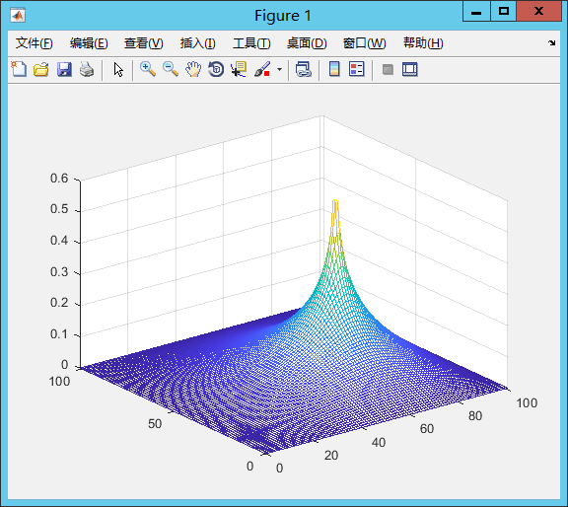The following figure is the concentration distribution of pollutant for $x_{1}$, $x_{2}$ and $x_{3}$.

**Figure 3** the concentration distribution of pollutant for $x_{1}$

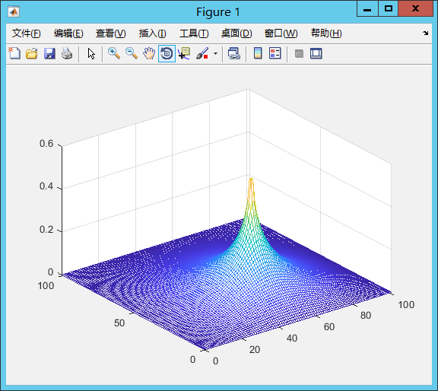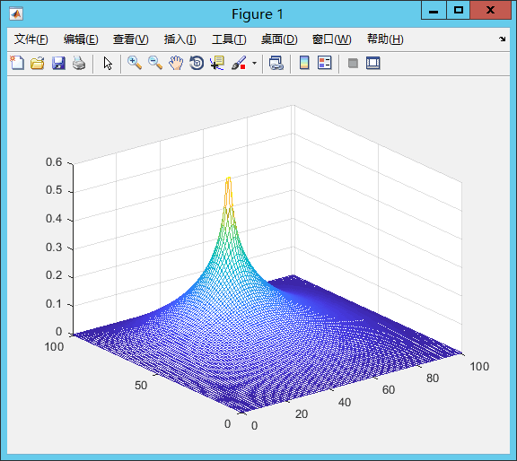**Figure 4** the concentration distribution of pollutant for $x_{2}$

**Figure 5** the concentration distribution of pollutant for $x_{3}$

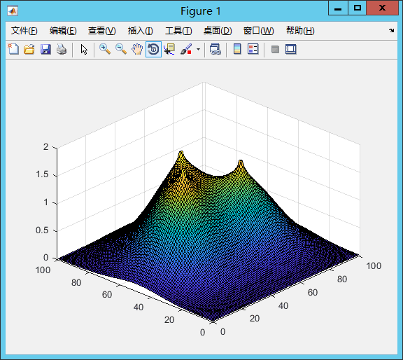The following figure is the final result of Model B:

**Figure 6** the final result of Model B

5. Model C: The annual budget

## 5.1 Model overview

In the model C, we will model for the government’s expenditure according to the total pollution units and the interest rate of the loans.

## 5.2 Variables of Model C

**Table 3** Variables of Model C

|  |  |
| --- | --- |
| Variables | Definition |
| κ $F_{j}$ | the rate of interest  the expenditure of the year $j$ to deal with the atmosphere pollution |

## 5.3 The annual budget

According to the given information, we can get the relation of the pollution units dealt with in a year and the fund may coat:

$$F_{total}=\sum_{i=0,j=1}^{4,5}{(1+κ^{i})(F_{j}+0.005*{F_{j}}^{2})}$$

In this model, the κ is the rate of interest, which is 6.4% every year. The $F_{j}$ is the expenditure of the year $j$ to deal with the atmosphere pollution. In this way, we can get the expenditure of each year when the total fund is the minimum:

**Table 4** the result for model C

|  |  |  |
| --- | --- | --- |
| The year | The dealt pollution units | The fund(million Yuan) |
| 1 | 32.95 | 48.20341 |
| 2 | 40.09 | 57.36624 |
| 3 | 48.04 | 67.20535 |
| 4 | 56.94 | 77.83247 |
| 5 | 66.98 | 89.4116 |
| Total | 245 | 340.0191 |

6 Sensitive Analysis

## 6.1 Sensitivity analysis of $v_{wind}$ and a

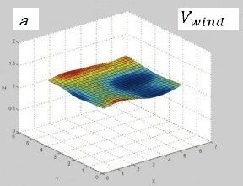

**Figure 7** Sensitivity analysis of v and a

In order to examine the sensitivity and the validity of our model, we do sensitivity analysis for the constants $a$ and $v_{wind}$ on our model and get the figure above. We can find that it is a smooth curve, which explainsthat our model is stable and fits our exception.

7. Strengths and weaknesses

## 7.1 Strengths

**1. Our model works steadily.**

Sensitivity analysis shows that our model is not easily disturbed by changes in its constants. Therefore, its results are relatively steady and reliable.

**2. Our model works ideally.**

The prediction given by our model ideally corresponds with mainstream points. In addition, there SA validate the stability of our model.

## 7.2 Weaknesses

**1. Our model involves a large operand**.

As our model involves huge amounts of data, the amount of calculation we need to conduct becomes enormous. This makes our model slow to operate and dependent on the quality of hardware.

**2. Our model relies on large amounts of data.**

To operate our model, great amounts of data are needed. When appropriate data is scarce, our model would be unable to function.

8. References

[1] University Physics – With Modern Physics (12th Edition), H.D. Young, R.A. Freedman (Original edition), Addison-Wesley (Pearson International), 1st Edition: 1949, 12th Edition: 2008, ISBN 978-0-321-50130-1

[2] Maxwell, J.C. (1860 A): Illustrations of the dynamical theory of gases. Part I. On the motions and collisions of perfectly elastic spheres. The London, Edinburgh, and Dublin Philosophical Magazine and Journal of Science, 4th Series, vol.19, pp.19-32.

[3] Cercignani, C. (2002), "The Boltzmann equation and fluid dynamics", in Friedlander, S.; Serre, D., Handbook of mathematical fluid dynamics, 1, Amsterdam: North-Holland, pp. 1–70, ISBN 978-0444503305;

[4] Temam, Roger (2001), Navier–Stokes Equations, Theory and Numerical Analysis, AMS Chelsea, pp. 107–112